Great Falls College MSU
Mindset & Emotions
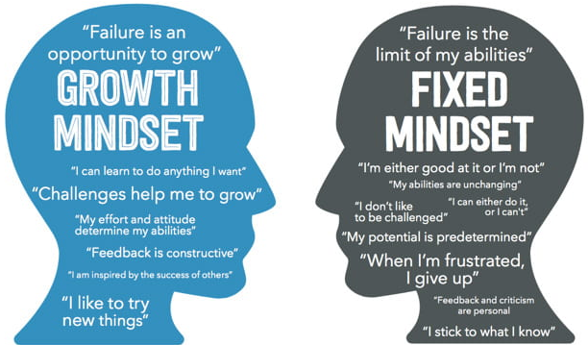
for Academic Wellness
Growth Mindset: believing that my
abilities can be developed
through hard work, dedication,
good strategies, and input
from others

Growth Mindset Strategies
- View a new challenge as a
new opportunity
- Prioritize learning not approval
- Enjoy the learning process
- Look at the big picture
- Choose to learn well
- Realize mistakes are OK
- Learn from the mistakes of others
- View constructive criticism as beneficial
- Cultivate perseverance and passion for my long-term goals
10. Set a new goal for every milestone I achieve
11. Realize it takes time to succeed

*Growth mindset = Achievement

Emotion: a mental reaction derived from my circumstances, mood, or relationships and is typically accompanied by body and behavior changes

Stress: a normal human reaction to changes or challenges
- Stress can be beneficial or harmful
  - My reaction to stress is key
Stress reduction techniques to try:
- Physical activity (see ‘Movement Break’ handout)
  - Running, walking, yoga, stretching, … the options are endless
- Mindful breathing or other mindfulness activity
- Sleep
- Prayer
- Journaling
- Apps: Calm, Headspace, Aura, Simple Habit, Stop Breath & Think, Take a break!, Meditation Timer, Smiling Mind, MINDBODY Connect

