Mindful Breathing
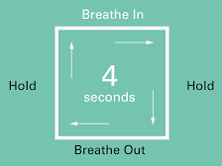
Box Breathing
- Slowly breathe in counting to 4 Feel the
air enter your lungs
- Hold your breath for 4 seconds
- Slowly exhale through your mouth for 4 seconds
- Hold your breath for 4 seconds
- Repeat as many times as you can 30 seconds
of deep breathing will help you feel more relaxed
and focused
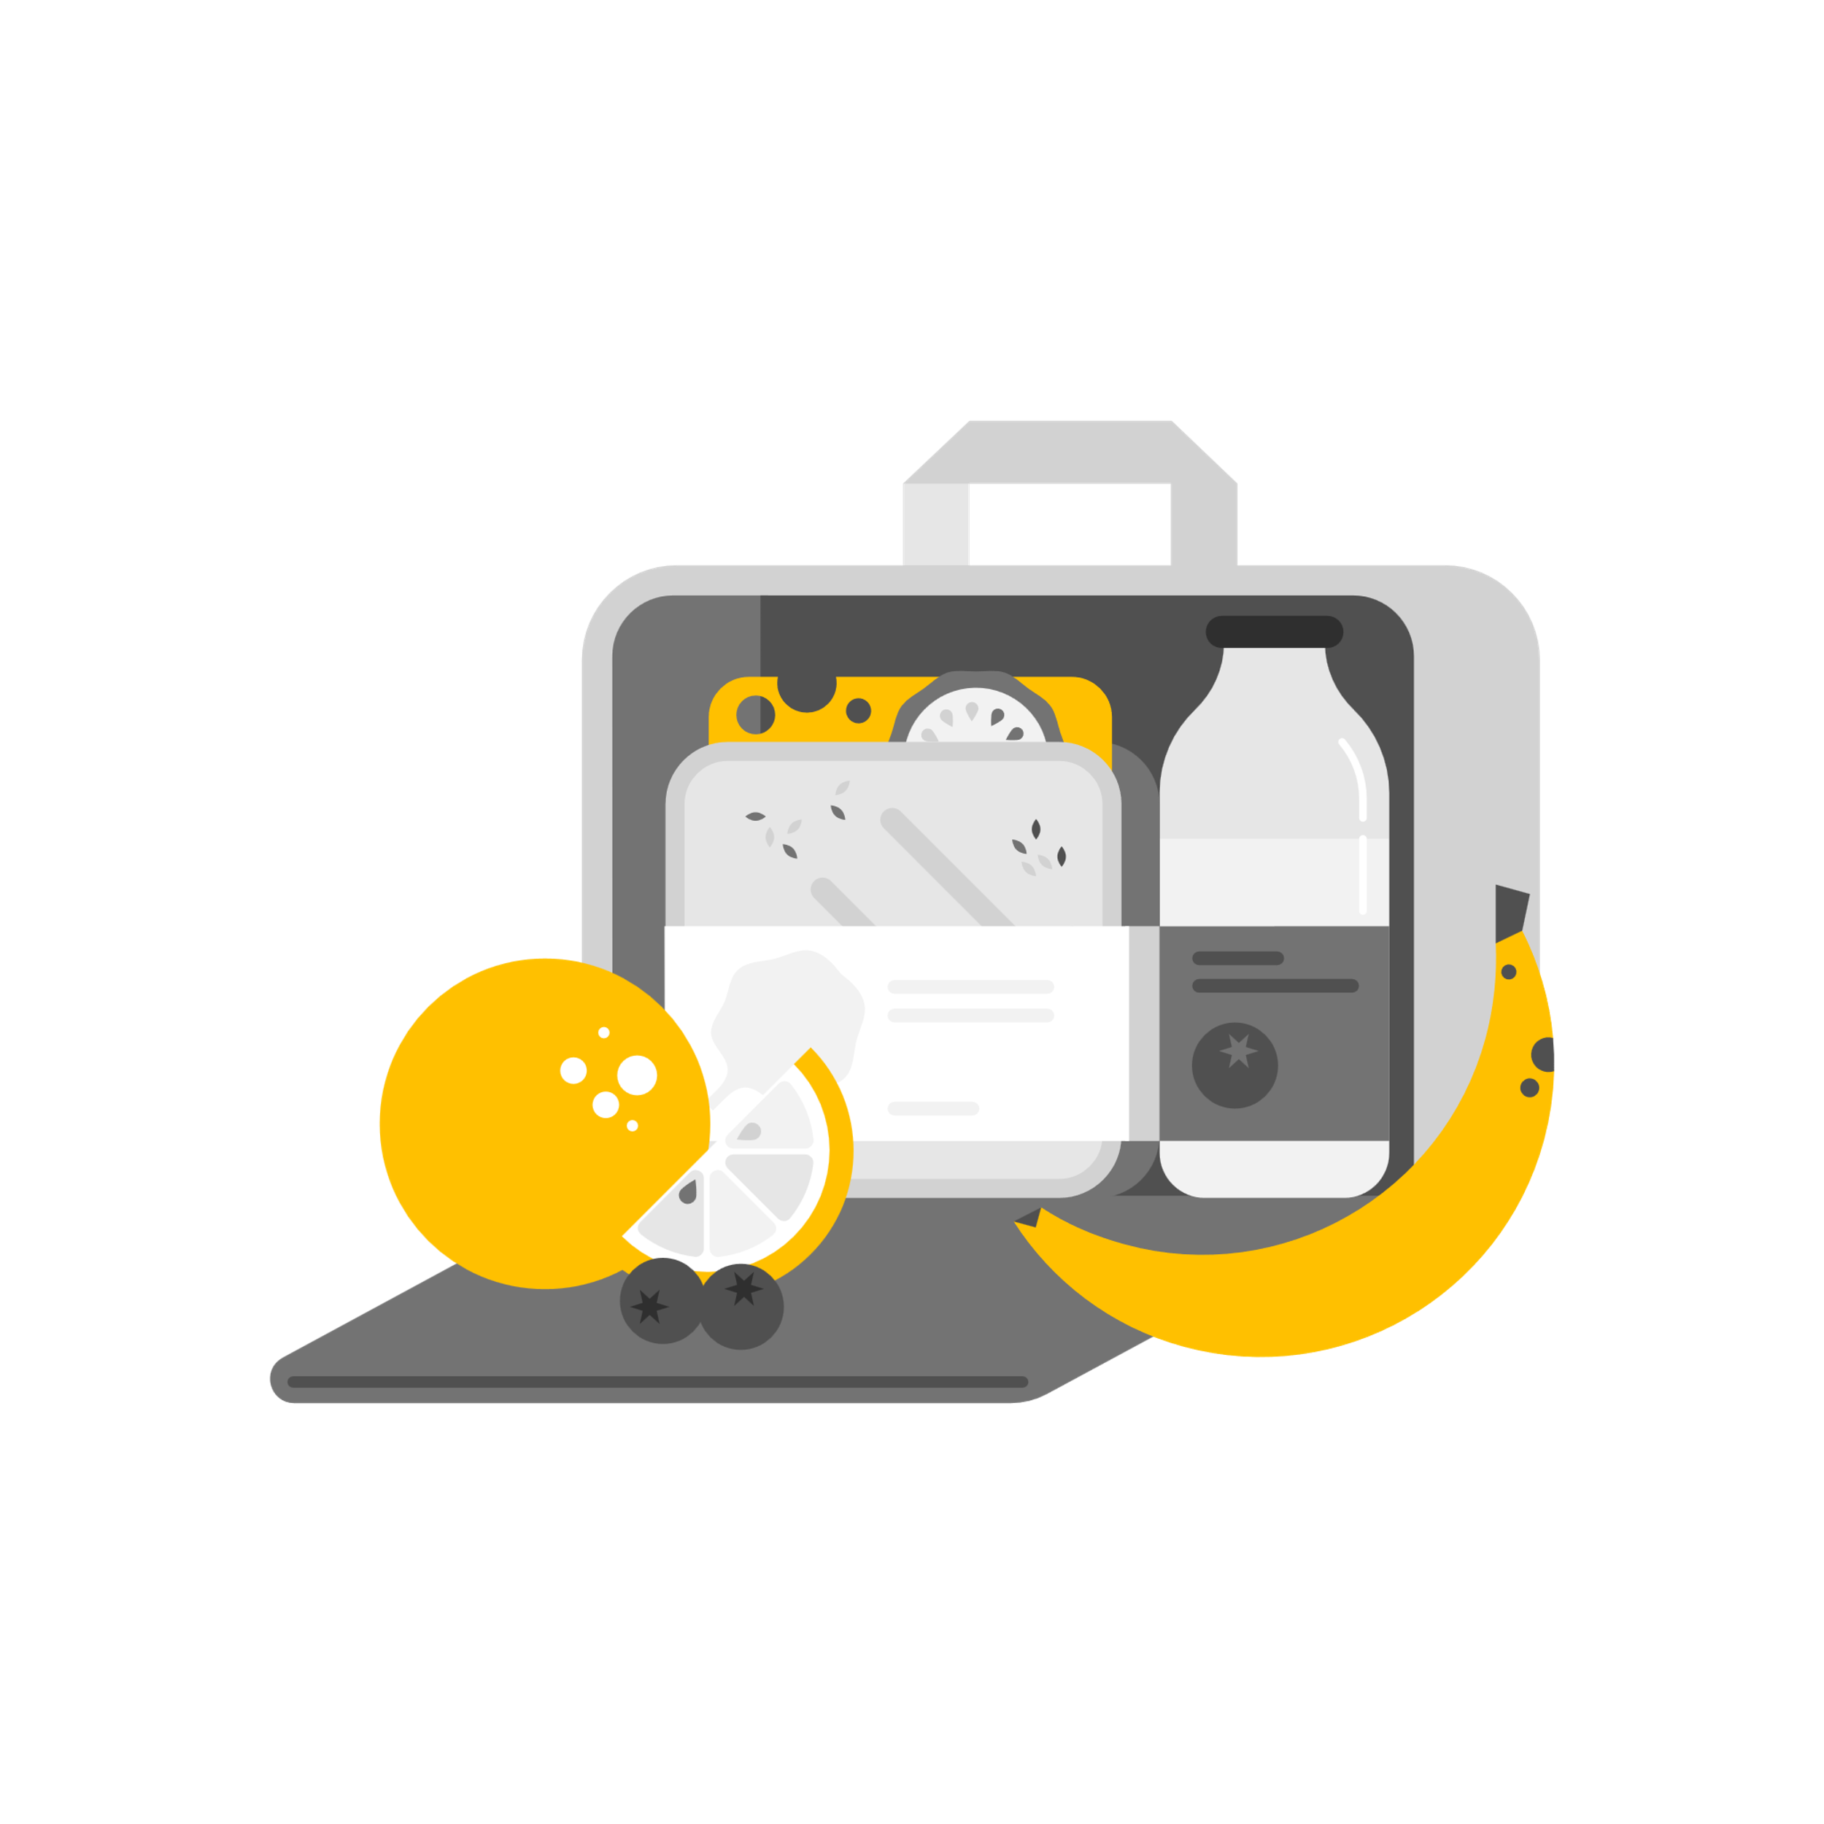
*Perform box breathing prior to an exam or presentation to reduce stress and anxiety

Mindful Eating
- Sit in a chair comfortably How does your body feel
- Bring your attention to the meal Notice the smell, color, shape,
temperature, texture, etc.
- Take a bite Notice the flavor, texture, temperature, sensation, etc.
- Swallow Imagine the food traveling from mouth to stomach
- Reflect How your body feels now compared to before eating

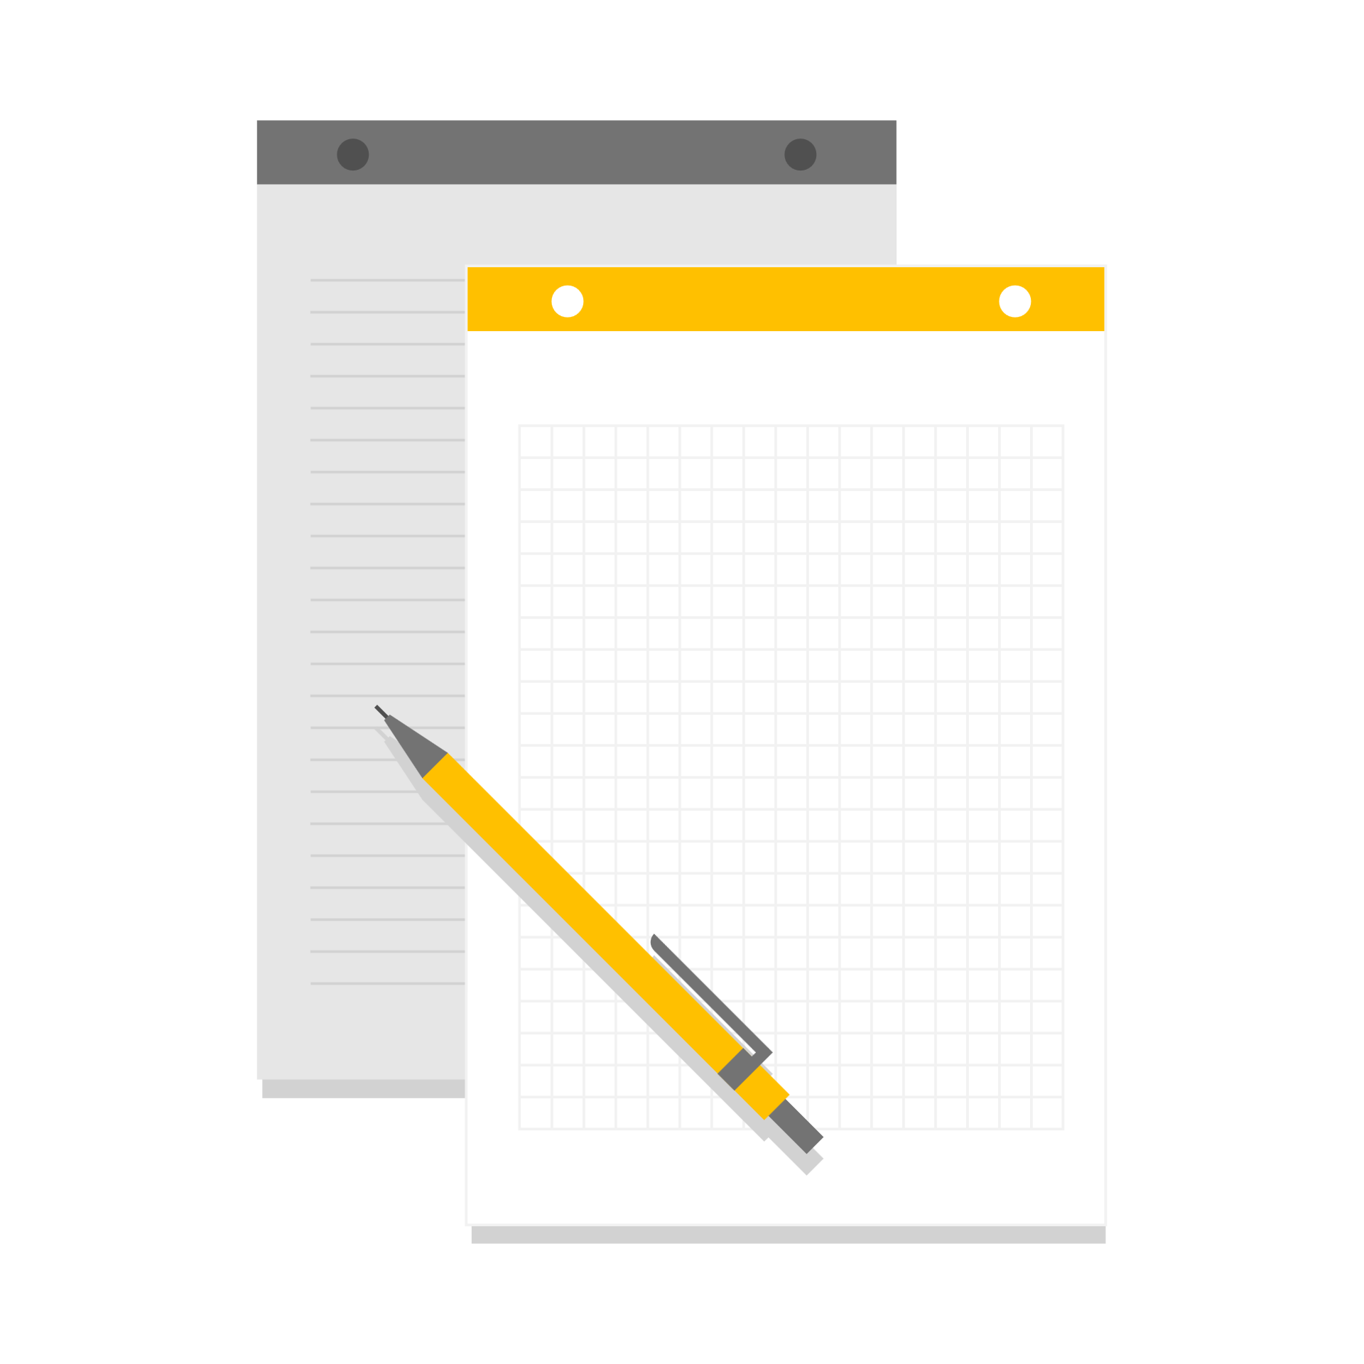
Single - Tasking
Single Tasking for School
- Clear study space of all distraction
  - move phone to different room
  - close extra computer tabs
  - find solitude area
- Before beginning your homework or study session
  - Take a minute to reflect – how are you breathing, how does your body feel, how is your body posture
- Focus
  - Set a timer to know when it’s time to move on to the next assignment or take a break (use the timer to notify you when your break is over as well)

